**Grants Management Reports Solutions**

1. Overview: The purpose of the Grants Management Report Solution (GMRS)

2. Solution Components:

a. Google Big Query

b. Google Data Studio Report

c. Google Data Studio Report Scheduled Email Delivery

d. Outlook 365 Shared Inbox

e. Power Automate Workflow

f. SharePoint Online Report Library

3. Architectural View:

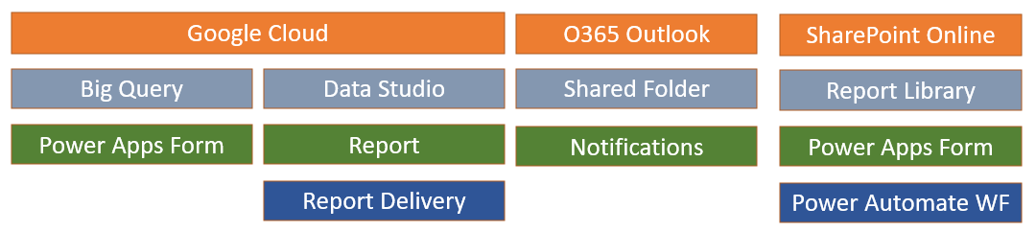

4. Process Flow:

5. Google Big Query:

a. Storage of All Grants Management Relational Data

b. Grants Management Reports Source for Google Data Studio

6. Google Data Studio Report:

a. Report Design Tool for Grants Management Reports

b. Also has Basic Reports Delivery Capabilities

7. Google Data Studio Report Scheduled Email Delivery:

a. Basic Reports Delivery Capability

b. Emails Report in PDF Format to Outlook 365 Shared Inbox

8. Outlook 365 Shared Inbox:

a. Provides a Location for Receiving Email Reports

b. Shared with Multiple Grants Management Team Members

9. Power Automate Workflow:

a. Detects Email Delivery to the Outlook 365 Shared Inbox

b. Copies Email Attachments to the SharePoint Online Library

10. SharePoint Online Report Library (Grants Reports):

a. Receives Copied Email Attachments from the Power Automate Workflow.

b. Contains Multiple Folders for Multiple Reports

b. Folders are Permission Controlled to Limit Access to the Appropriate Individuals

11. Power Automate Screen Shots:

a. Workflow Overview:

b. Step 1: “On new email with attachment”:

c. Step 1 Workflow Log: “On New Email with Attachment - WF Log”:

d. Step 2: “Initialize variable”:

e. Step 2 Workflow Log: “Initialize Variable - WF Log”:

f. Step 3a: “Condition”:

g. Step 3b: “If Yes”:

h. Step 3b Workflow Log: “Condition Met ‘Yes’ - WF Log”

i. Step 3c: “If No”:

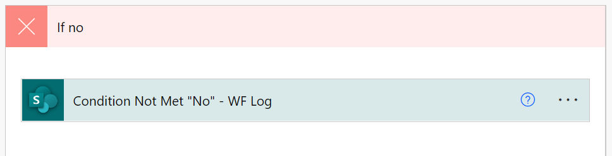

j. Step 3c Workflow Log: “Condition Not Met ‘No’ - WF Log”

